P250/1

**PHYSICAL GEOGRAPHY**

JULY/AUG

PAPER 1

3 HOURS



KAYUNGA SECONDARY SCHOOLS HEAD TEACHERS AND PRINCIPALS’ ASSOCIATION (KASSHPA)

JOINT MOCK EXAMINATIONS, 2023

Uganda advanced Certificate of Education

**(PHYSICAL GEOGRAPHY)**

PAPER 1

3HOURS

***INSTRUCTIONS TO CANDIDATES;***

* *This paper consists of three sections A, B and C.*
* *Answer four (4) questions.*
* *Section A is compulsory*
* *Answer one question from section B and one question from section C.*
* *Credit will be given for use of relevant sketch maps, diagrams and specific examples studied in the field.*
* *Any additional question (s) attempted will not be marked.*

**SECTION A**

*(Question 1 and 2 are compulsory)*

**COMPULSORY MAP WORK QUESTION**

1. Study the 1:50,000 EAST AFRICA (UGANDA) BUDADIRI map extract series Y732 part of sheet 54/4, Edition 2-U.S.D and answer questions that follow:
2. (i)State the grid reference of the bridge at Budeda. (01 mark)

(ii)Calculate the area covered by the mount Elgon forest Reserve South of Northing 20 (01mark)

1. Draw a sketch map of the area shown on the map extract south of Northing 20, between Eastings 46 and 56 and on it mark and name ;

(i) two Physiographic features,

(ii) Bududa- Buwangani loose surface ring road.

(iii) Forest vegetation cover

(iv) River manafwa and its tributaries.

(v) Water shed. (10 marks)

(c) Describe the physical landscape of the area shown on the map extract.(04 marks)

(d) Explain the influence of social services on settlement in the area shown on the map. (06 marks)

(e) Explain the value of mount Elgon Forest reserve to the people living in the

surrounding areas. (03marks)

**COMPULSORY PHOTOGRAPH INTERPRETATION QUESTION**

1. Study the photograph provided and answer the questions that follow:

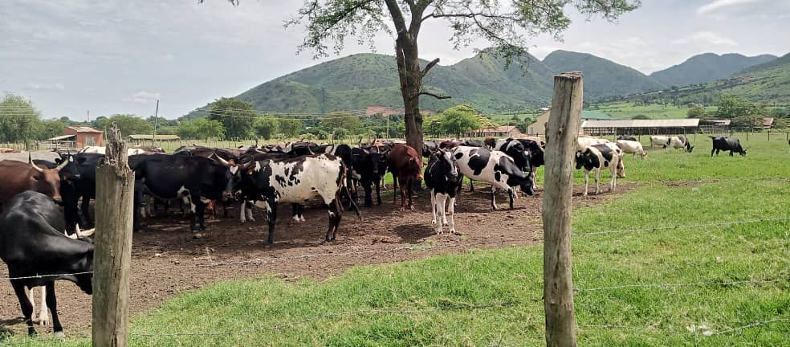

(a). Giving reasons for your answer, state the type of photograph provided. (02marks)

(b) Draw a landscape sketch of the area shown on the photograph and on it mark and name any;

(i) three relief features

(ii) two vegetation types

(iii) settlements (09 marks)

(c). (i) with evidence, state the economic activity taking place in the photograph. (02marks)

(ii) Explain the impact of the activity identified in (c)(i) above on the physical

environment. (05marks)

(d) Account for the formation of the relief land form in the foreground of the

photograph (05marks)

(e) Giving reasons for your answer, state one area in East Africa where this photograph

could have been taken. (02marks)

**SECTION B**

*Answer one question from this section*

1. Justify the theory of continental drift as explained by Alfred Wegner. (25 marks)
2. Examine the influence of sedimentary rocks on landform development in E. Africa.

(25 marks)

1. (a) Describe the characteristics of the long profile of a river. (12 marks)
2. Examine the processes responsible for the formation of water falls in the upper course of the river in E. Africa. (13 marks)

**SECTION C**

*Answer one question from this section*

1. To what extent have the wind systems influenced the climate of E.Africa?

(25 marks) (25marks)

1. (a) To what extent has altitude influenced the growth and distribution of natural

forest vegetation in E. Africa? (19 marks)

(b) Explain the value of forests to man in East Africa. (06 marks)

1. (a) Distinguish between the pedalfers and pedocals. (06 marks)

(b) Examine the processes of formation of mature soils on the northern shores of

Lake Victoria. (19 marks)

**END**